Predicting the Current and Incoming Trend in Hip-Hop Fashion, in the Relationship with Music: Utilizing Image Machine Learning and Testing

Minsung Parka

aUnderwood International College, Yonsei University, Seoul, South Korea

minsungp5035@yonsei.ac.kr

# Introduction

## Significance Hip-Hop

Music is significant in understanding culture. Among many genres, hip-hop is the music genre that is becoming very popular since 1970 and has expanding fandom all over the world.

However, there are various genres inside hip-hop and they all have different styles of music and fashion. As the significance of hip-hop is getting larger, the understanding about it is crucial in communication and future marketing. Thus, through one’s hip-hop fashion, this paper allows to predict what genre of hip-hop one favours.

## Research Objective

This research will utilize machine learning and a visualization system to view what kind of fashion corresponds to different type of music.

This research focuses on finding musical preferences of people, in search for what hip-hop genre would prosper in the future, to assist brand strategies of music and fashion industries.

In literature review, this paper will verify the premises that music and fashion are closely related to each other.

# Literature review

## The Relationship between Fashion and Music

In this paper, research is conducted on the basis of the premise that one’s preference for music affects his/her fashion style. In the research by Na and Agnhage, (2013), one of their objectives was to find “the relationship between preferred music genre and fashion style”. The paper investigated how strongly preference styles of music and fashion correlates with each other by survey questionnaire on college students during April-May 2011, with the gender ratio of 1:1. By analysing data from survey, they suggest that music and fashion have a very strong correlation, showing the table for correlation between tastes in music and fashion according to people’s interest in music (Figure 1).

Another research by Badaoui, Lebrun, and Bouchet (2012) showed the relationship between fashion and music, focusing on adolescents. They put “an adolescent’s sensitivity to music influence varies according to the clothing style to which the adolescent adheres” as one of the hypothesis (H6), and conducted a survey of sample consisting 1063 adolescents with the mean age of 15.35 and standard deviation of two years. Utilizing the Kruksal–Wallis ANOVA and the medians test, the paper showed that adolescents’ sensitivity to the influence of music significantly impacts their clothing style identification. Hypothesis H6 is validated with this analysis, which shows evidence that music is strongly correlated with fashion preferences.

## The Effects Musicians—as Influencers—Have on Fashion Styles of Audiences

Other than music itself, the artists who provide such music have effects on audiences’ fashion. With the development of social networking services, the public, especially the fans of artists live in a world where it is easy to receive information about artists’ news.

Kim and Choo illustrate how influencers effect consumers on their purchase habits. Here, they give the definition that fanship means consumers engaged in consumption with cognitive, affective, and behavioural loyalty (2017). From this kind of fanship, purchasing the products influencers founded or promoted forms them certain bond, increasing product purchasing intention as a whole.

One representative example of a rapper influencing over a brand can be found in the paper by Chung, Lee, and Jeremy (2018). They were doing a research about 5 High-Fashion brands (Channel, Dior, Gucci, Burberry, and Louis Vuitton) showing up in instagram from 2016 to 2018. They set up #keyword for each brands, and one peculiar hashtag that came up frequently while analysing Gucci was “#guccigang”. The researchers mentioned that “#guccigang was much more repetitively shown up on posts…showing that consumers feel high attachment and sense of belonging” to this brand, and assumingly with the rapper, too. Gucci Gang is a hip-hop song by Lil Pump, a famous rapper, released in 2017. This song mentions the brand in both its title and lyrics. In the graph—made with big data—in another paper by Huh and Lee, Gucci had explosive uptrend together with the release of the song “Gucci Gang” (2019) (Figure 3).

Moreover, at 2019 October 4th, a keyword “염따 티셔츠” recorded 1st place in Naver portal real-time search word trend. A Korean rapper called Yumdda made his products—slippers, hoodies, and T-shirts for his fans, and opened a market for a week. One surprising fact is, that he earned profit over 2 billion won in that one week (data from his official youtube). Even if the quality of the goods weren’t that good, and the clothes weren’t from official brands, numerous fans bought them with fanship, and astonishing results were able to come out.

These features show how hip-hop artists function as influencers that effect purchase and style of fashion.

## The Classification of Hip-Hop as Music Genres and Fashion Styles

Lee (2013) analysed hip-hop fashion over time periods, relating genre and style in hip-hop culture.

### 1980s

* Old School - Training suits (especially sports brand Adidas), gold necklace and accessories, monotone.
* New School – More loose clothes, less heavy accessories, use of primary colors, baggy pants.

### 1990s

* Heavy, chained necklace to cross necklace
* East Coast – Free style, bandana, big cross pendants, oversize sports jumper, baseball cap
* West Coast – gangster style, colourful and luxurious clothings, tattoos, cornrow style.

### 2000s

Trap genre, and various – skeleton bustles, goodies, vintage shirts, tight denim jeans. Luxurious suits and sunglasses. Sneakers.

## Limitations

There are artists who may wear clothes that do not accord with their music genre.

As hip-hop becomes the majority, its specific genres inside are getting more diverse. New genres are created, and there is numerous music which have more than two styles combined inside. For example, a song called 공중도덕 (Air DoTheQ) has two different styles of beats mixed inside, so this music cannot be defined as a certain genre of hip-hop.

The most important point is that music and fashion are both in the category of art. Since art highly depends on artists’ individuality, it would be often hard to predict one’s style solely based on the music genre.

However, in most cases, many artists desire popularity and thinks about the match of overall mood of their fashion and music. Thus, despite some outliers, general correlation between certain genre and music would not differ in a large degree.

# Methodology

## Determining the Definitions of Important Terms

In this paper, “fashion” is defined as overall social phenomenon and trend, not only regarding one’s style of wearing clothes.

“Fashion style” refers to individual styles of wearing clothes.

Early 1980s fashion is defined as “Old School Hiphop”, which have features of African-American style Reggae and sportive style. Track suits, Hood shirts with labels, sneakers, many rings and necklaces. Usually with Dreadlocks hairstyle and red-black-green colored fashion.

Later 1980s fashion is defined as “New School Hiphop”, which have features of bright color fashion, Dickids pants, Black Riders Jacket, baseball hat, Dr.Martins boots, chunck taylors’ sneakers.

1990s fashion have features of bowler hat, double breasted suit, silk shirt, and gangster looks. Beginning of harmony with High-end brands.

They all have common feature of fashion: Large baggy denim pants, big jersey Tshirts, luxury accessories and sneakers.

After 2000s, various looks appeared. Representative threads of fashion are:

Prep-Hop, Slim Formal Suits, Skurban (Skater meets Urban), Hip Hop Goth styles.

## Labelling Hip-hop Genre and Listing Artists for Data

For the preparation of dataset, this paper investigates 100 foreign hip-hop artists and their fashion. Foreign hip-hop genre was divided into 5 main categories: Boom Bap (East Coast), Gangster/G-Funk (West Coast), Dirty South, Singing Rap, and Trap. 20 artists were researched for each of the categories.

The list of artists was made by searching: “best ‘genre (5 types)’ rappers” in google search engine, and artists were randomly picked out of the list (Figure 5).

## Collection of Data

List of 100 foreign hip-hop artists, 20 artists for each of the genre, was made.

The 5 genres are defined as “classes” and are numbered 0 to 4. Boom Bap (East Coast) class was numbered 0, Gangster/G-Funk (West Coast) class was numbered 1, Dirty South class was numbered 2, Singing Rap class was numbered 3, and Trap class was numbered 4.

Fashion (features) was divided into 9 categories: Color, Headwear, Outer, Set, Top, Accessories, Bottom, Shoes, and Piercings.

Then, they were divided into various subcategories.



















Viewing the artists’ overall fashion style, if he/she had the feature of fashion frequently, then that feature was marked as 1. If else, 0.

Then, using google image search, artists’ typical fashion style was investigated.

“‘Artist Name’ style/fashion” was searched up.

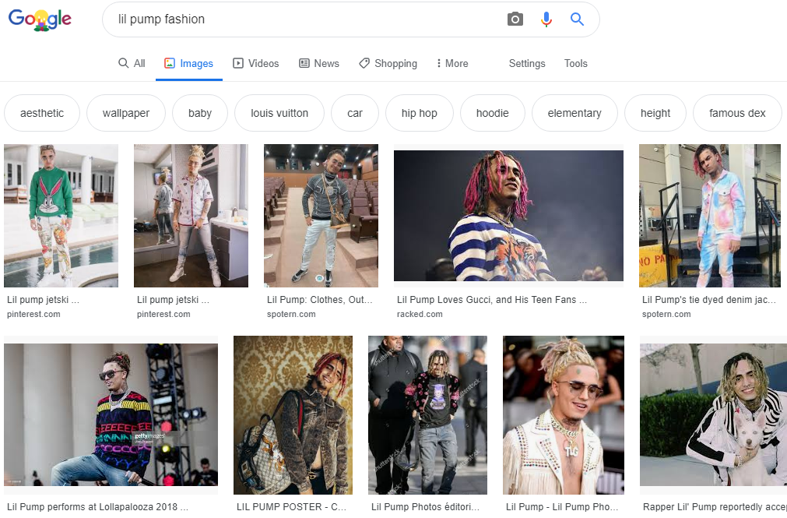

<Example of search keyword>

For example, when “Lil Pump fashion” was searched, there were many pictures with vivid colors, but not much pictures with achromatic (dull) color clothes on. There were almost no pictures with cap or bucket hat on, and there were pictures with fancy suits and chains. So he was given 1 for vivid, 0 for achromatic, 0 for headwears, 1 for suit, and 1 for chains.

All 100 rappers were researched in this pattern, for 19 categories (features) of fashion. The processed data is saved in an excel file.

## Python Coding

This paper used google colab for python coding.

Imported modules with the code:

import pandas as pd

import numpy as np

import pandas as pd

from sklearn.tree import DecisionTreeClassifier # Import Decision Tree Classifier

from sklearn.model_selection import train_test_split # Import train_test_split function

from sklearn import metrics

from sklearn.tree import export_graphviz

from sklearn.externals.six import StringIO

from IPython.display import Image

import pydotplus

Imported dataset of Hip-hop rappers’ fashion by mounting google drive and uploading the excel file:

from google.colab import drive

drive.mount('/content/drive')

from google.colab import files

uploaded = files.upload()

import pandas as pd

df = pd.read_excel(r'/content/final.xlsx')

Dataframe could be read by defining it as df.

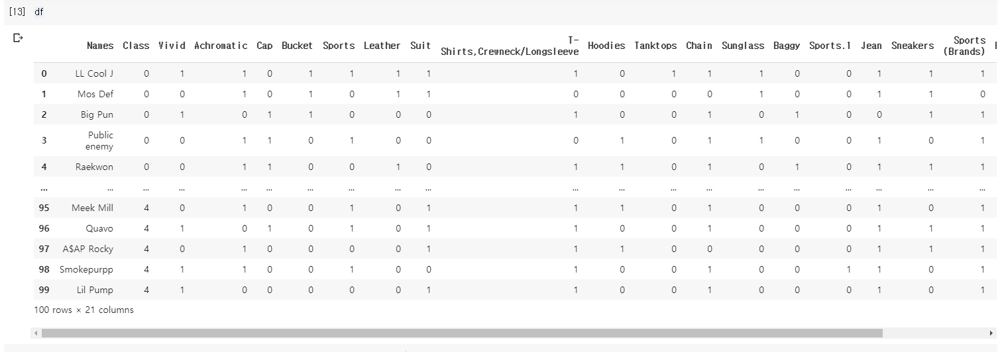

<Excel Data shown in Python>

19 feature columns were defined and used as x axis. Genre of music was defined as classes, numbered, and used as y axis:

feature_cols = ["Vivid","Achromatic","Cap","Bucket","Sports","Leather","Suit","T-Shirts,Crewneck/Longsleeve","Hoodies","Tanktops","Chain","Sunglass","Baggy","Sports","Jean","Sneakers","Sports (Brands)","Boots/Heels","Piercings"]

y = df.Class

X = df[feature_cols]

Split 100 rows of data into 70 and 30 rows for training and testing:

X_train, X_test, y_train, y_test = train_test_split(X, y, test_size=0.3, random_state=1)

Set decision tree criterion as “entropy”, train the module, and predict:

clf = DecisionTreeClassifier(criterion="entropy")

clf = clf.fit(X_train,y_train) #Training

y_pred = clf.predict(X_test) #Make a prediction

Check the accuracy of the test set:

print("Accuracy:",metrics.accuracy_score(y_test, y_pred))

Then, visualize Decision Tree, and save data as png:

dot_data = StringIO()

export_graphviz(clf, out_file=dot_data,

                filled=True, rounded=True,

                special_characters=True,feature_names = feature_cols,class_names=['BoomBap (East Coast)','Gangster/G-Funk(West Coast)','Dirty South','Singing Rap','Trap'])

graph = pydotplus.graph_from_dot_data(dot_data.getvalue())

graph.write_png('hiphopfashion.png')

Image(graph.create_png())

The graph will be shown in “results” section.

## Reason for selecting Decision Tree

There are many variables to classify in a single fashion style. Fashion styles couldn’t be defined as a single category since they are in the domain of freedom and art. However, what this paper wants is the overall trend of fashion, and the continuous particular features of fashion styles that allow the people to distinguish what styles of fashion and music what artist prefers.

Thus, since decision tree allows various amounts of variables to be used when training and testing datasets, this algorithm seemed to be the best choice when analysing such data.

# Results

With accuracy of “Accuracy: 0.5666666666666667”, the decision tree could be visualized.

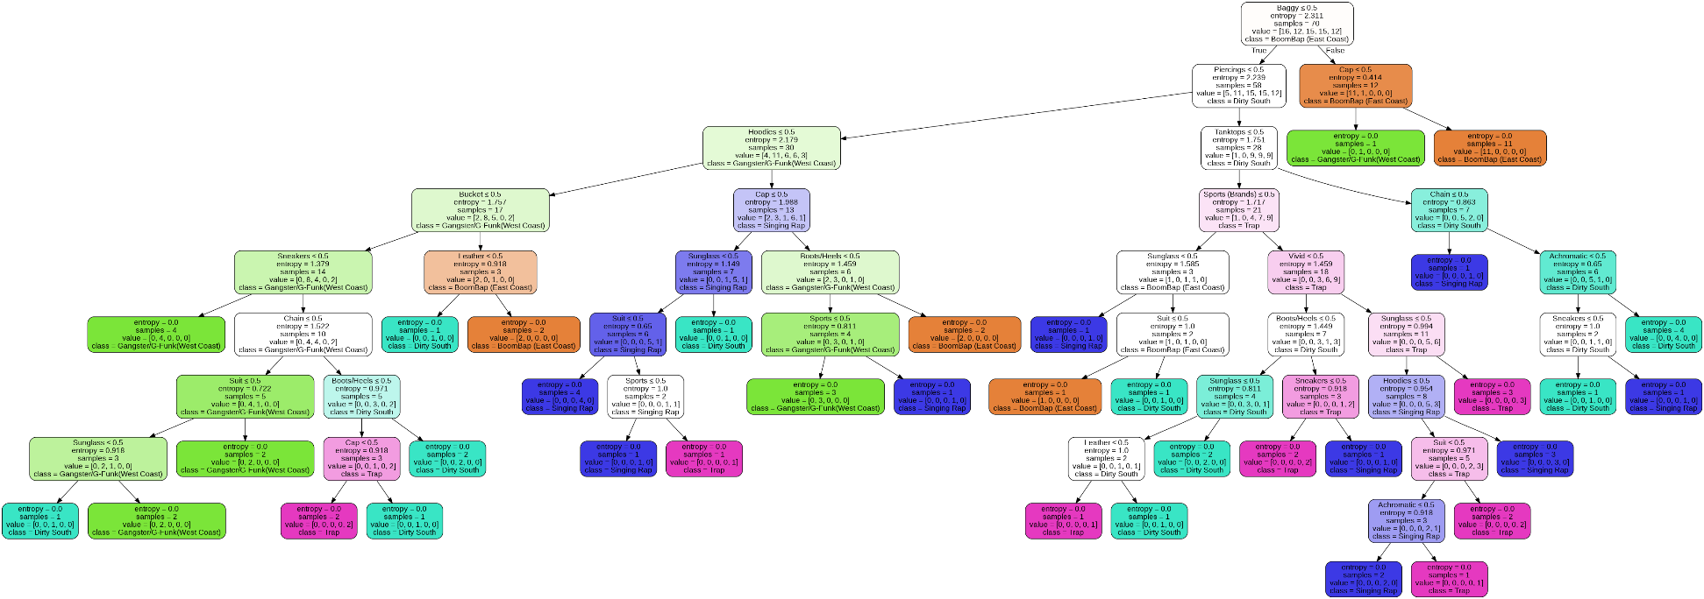

When a sample answers their fashion preferences (features), this model helps to find the music preference of that sample with accuracy of 56%.

For example, if the sample answers that he/she frequently wears baggy pants and wear a cap, the model predicts that the sample listens/prefer to listen Boom bap (East Coast) hip hop.

# Discussion

## Expectations

This model can be used in predicting people’s preferences in music according to their outfits.

## Limitations

The research has many shortages.

The decision tree does not have high accuracy of prediction, so advancements would be needed for practical uses. Furthermore, the model would have even lower accuracy when predicting market trends, due to the point that fashion and music falls under the category of art.

Moreover, the data was collected manually by the researcher, so there is a lack in sample amount and accuracy in collecting data to establish the model into a professional prediction. Also, the genres of hip-hop and the categories under fashion is much diverse than the categories used in the paper. Overall, the model inevitably lacks in accuracy.

# Conclusion

It is significant that there are certain clear fashion features that comes with the according genre of hip-hop. The relationship between music and fashion seems tight in bond. More research with additional data would make a better model that can predict one’s musical preferences with higher accuracy.

# Reference & Appendix

Figure 1.

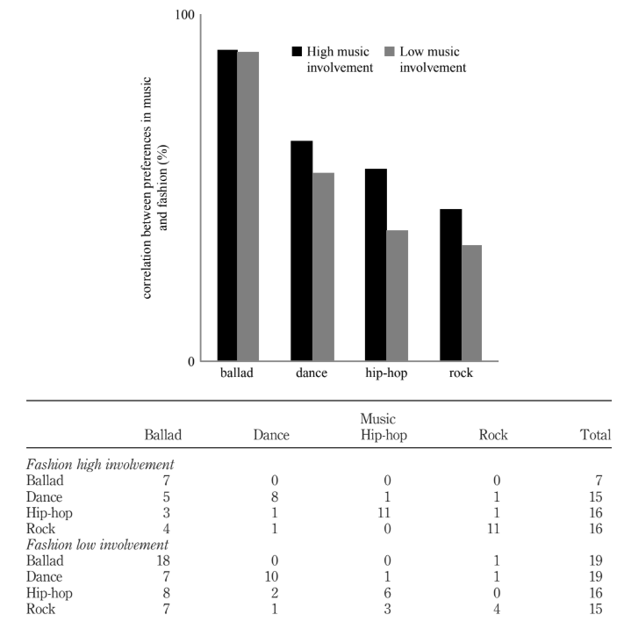 Correlation between tastes n music and fashion according to people’s interest in music

Figure 2

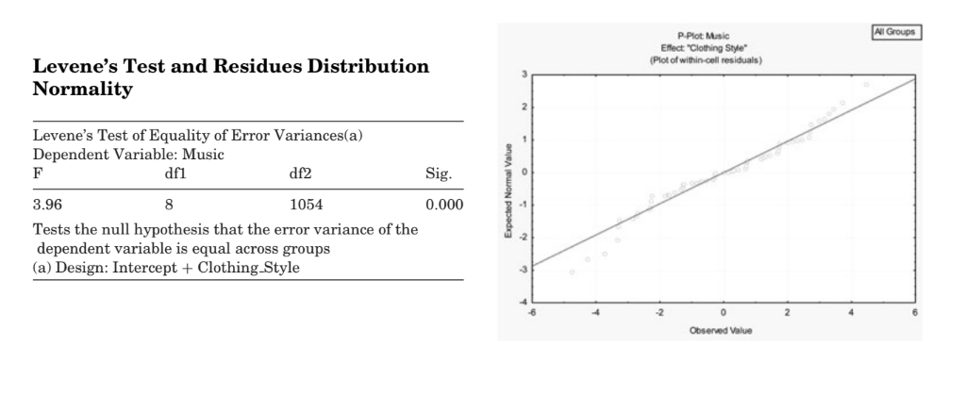Relationship between music and clothing style

Figure 3

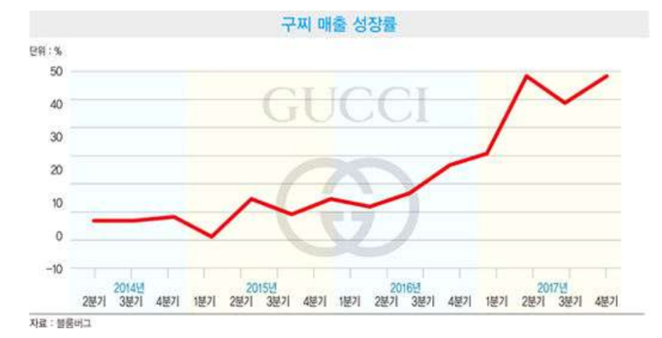

Gucci growth rate

Figure 4

|  |  |  |
| --- | --- | --- |
|  | **Korea** | **Foreign** |
| 1980s | Data X | 25 |
| 1990s | 25 | 25 |
| 2000s | 25 | 25 |
| 2010+ | 50 | 25 |

Figure 5

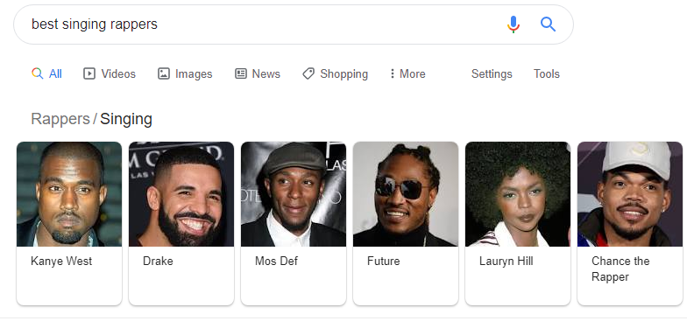

Example of artist search

References:

Na, Y., & Agnhage, T. (2013). Relationship between the preference styles of music and fashion and the similarity of their sensibility. International Journal of Clothing Science and Technology, 25(2), 109-118.

Badaoui, K., Lebrun, A. M., & Bouchet, P. (2012). Clothing style, music, and media influences on adolescents’ brand consumption behavior. Psychology & Marketing, 29(8).

Miller, J. (2011). Fashion and music. Bloomsbury Publishing.

김우빈, 추호정. (2017). SNS 패션 인플루언서의 진정성이 소비자 행동의도에 미치는 영향. 한국유통학회 학술대회 발표논문집, (), 233-240.

Chung, Kyung Hee, Lee, Mi Suk, Jeremy, Scott Bissett. (2018). A Study on the Everydayness of High Fashion on Social Media Platforms. JOURNAL OF THE KOREAN SOCIETY DESIGN CULTURE, 24(3), 533-554.

Junseok Huh, Eun-Jung Lee. (2019). Trend Analysis of Fashion Brand Evaluation Using Big Data - Focusing on Gucci Brand -.  Journal of the Korean Society of Costume, 69(6), 38-51.

Young Jae Lee. (2013). A Study on Their Impact on Popular Music and Popularized of Street StyleⅠ -Focus on Hip-hop Music & Musician Fashion-. JOURNAL OF THE KOREAN SOCIETY DESIGN CULTURE, 19(4), 501-512.